1.7 Centers of Mass Worksheet

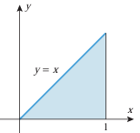
- Determine the centroid of the region shown in the picture on the right.

- Determine the centroid of the region shown in the picture on the right.

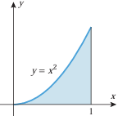

- Determine the centroid of the region shown in the picture on the right.

